ISL2024 Industrial Visit at Toyota Thailand (Gateway Plant)
Date: July 10, 2024 Time: (departure) 07.00 am.-01.00 pm (return).
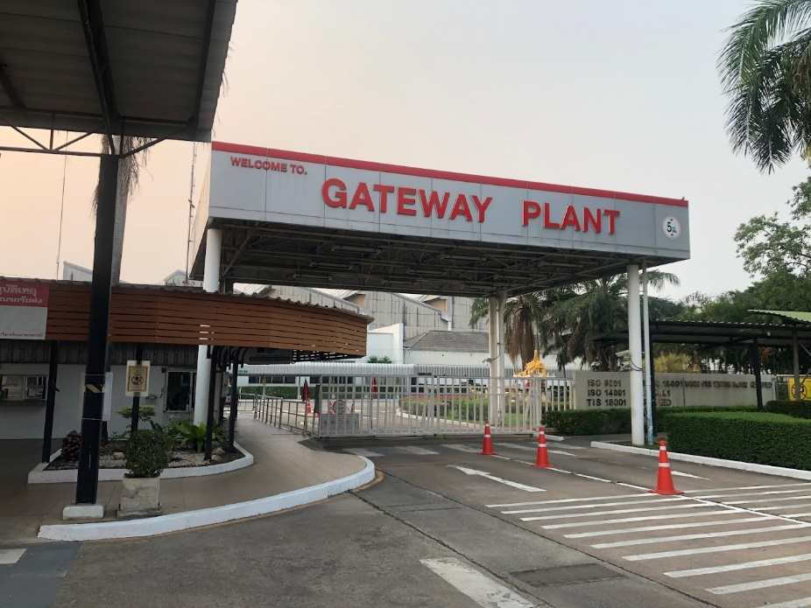

Gateway Factory Established in 1996 at the Gateway Industrial Estate, Chachoengsao Province, on an area of over 625 rai, producing and assembling 5 models of passenger cars: Camry, CHR, Corolla Altis, Vios and Yaris based on the Toyota Production System (TPS). Talented and skilled employees be meticulous in every process and work according to the standards set. Fully equipped with modern technology It takes time to assemble the car at production speed (Takt Time (T/T)) of only 58 seconds.
The Gateway factory consists of four main processes: 1. a body parts stamping shop, 2. a body parts welding shop, 3. a painting shop, and 4. an assembly shop. In addition, there are two sub-processes, namely welding of the suspension assembly. injection plastic parts Every process will be meticulously inspected for quality. By the quality inspection agency After the design process and the process of selecting parts manufacturers that meet world-class standards.
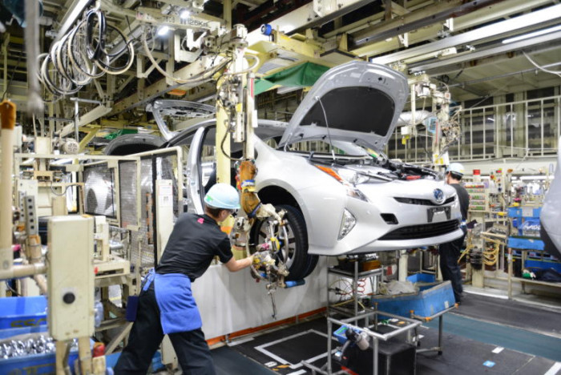

The context of increasing productivity by using the Toyota Production System (TPS) is not only about increasing the amount of production even more. But it also covers the use of fewer resources. But the same amount can be produced as before. or even production to suit the needs of customers or consumers This point is consistent with Toyota's policy of trying to focus on the importance of customers. We try to be flexible and change ourselves. according to demand both in terms of quantity, quality and keeping up with various trends in society. Hence, Toyota Gateway has therefore set a direction that places importance on flexibility in work (Flexible) in order to support competition on the basis of good ethics.

